TITLE OF THE INNOVATION
Context-Aware Emotion Expression Evaluation and Optimization Engine (CAEEOE)

📘 PREAMBLE OF THE DESCRIPTION
CAEEOE borrows concepts from the fields of data structures, probability theory, and artificial intelligence to create an entirely new method for processing emotions in texts. When you input an expression of your feeling—such as anger, excitement, or uncertainty—the program analyzes it, making sense out of raw emotional experience with intelligent parsing algorithms. In other words, it enables us to organize and make sense of emotions expressed in texts.

📖 DESCRIPTION
🔹 FIELD OF INNOVATION
The field of innovation is Data Structures and Algorithms, with interdisciplinary applications in:
• Artificial Intelligence
• Natural Language Processing
• Sentiment Analysis Systems
• Human Computer Interaction
The innovation integrates expression evaluation using stacks, probabilistic assessment, and emotion identification using artificial intelligence techniques.

🔹 REASON FOR THE INNOVATION
Classic sentiment analyzers:
• Produce only basic polarity (positive, negative)
• Have no structure for expression analysis
• Lack mathematical model of emotions

The same way, classic infix-to-postfix parsers:
• Work only with number expressions
• Cannot handle real emotions
Our approach resolves this issue with:
• Conversion of emotion to expression
• Probabilistic model of emotion analysis

🎯 OBJECTIVE
• Emotional Expression Processing Using AI
• Implementation of AI with Data Structure
• Emotion Analysis Using Probability
• Contextual Understanding of Emotions
• Low Ambiguity in Sentiment Analysis
• Real-Time Analysis and Scoring of Emotions
• Natural Language Processing Adaptability
• Mathematical Modeling of Emotions

✨ NOVELTY
🔹 Conversion of Emotional Word to Expression
In this model, emotions derived from a sentence are converted to an expression in mathematics, whereby emotions are assigned numerical values and combined through various operators including AND (*) and OR (+).
________________________________________
🔹 Emotion Extraction using NLP Method
The computer program employs NLP to examine the sentence, extract emotions, and classify the emotions as either positive, negative, or neutral.
________________________________________
🔹 Infix to Postfix Conversion via Stack
After the creation of the infix expression, the expression is changed to postfix notation through the use of a stack.
🔹 Probabilistic Model for Emotions Assessment
Every emotion is assigned a value from 0 to 1, which is the probability that the respective emotion is present in the input text. The postfix notation is calculated to get the result of emotional assessment.
________________________________________
🔹 Context-Sensitive Weight of Emotions Allocation
The program takes into account the context while evaluating the weight of each emotion. Words like “very” and “slightly” affect the intensity of the feeling and make the evaluation more precise.
________________________________________
🔹 Immediate Emotion Analysis
The program evaluates emotions and calculates the results immediately after receiving the input.
________________________________________
🔹 AI + Data Structures Concept
The suggested system uses the concept of Artificial Intelligence in combination with Data Structures in order to develop an effective solution.
________________________________________
🔹 Adaptability in Natural Language Interpretation
The system can interpret a variety of natural language constructions flexibly.
🔹 Formalized Representation of Emotions using Mathematics
Emotions can be formalized into structured representation using mathematics, which makes their processing, analysis, and evaluation easier.
_________________________________________
🔹 Combined Approach of AI, DSA, and Probability
In this system, AI has been used for the purpose of detection, Data Structures for expressions, and Probability for evaluation purposes.

BRIEF DESCRIPTION OF THE
INNOVATION
This innovation is composed of the following units:

• Text Entry System (Text Input System)
• Emotional Recognition System (Artificial Intelligence-driven)
• Infix Expression Construction System
• Converting Stack (Postfix Stack Converter)
• Probability Evaluation System
• Contextual Analysis System
• Results Output System
- FLOW CHART
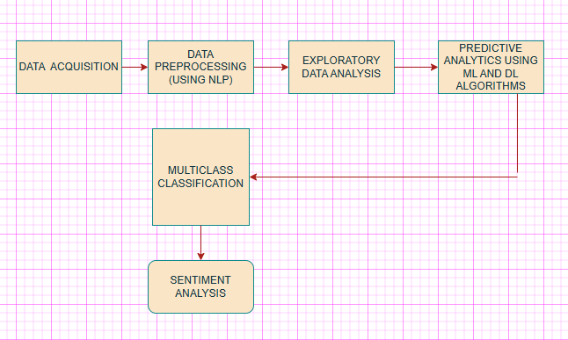

⚙ WORKING OF THE ALGORITHM
🔹 Emotion Recognition Algorithm
In this case, the algorithm analyzes the input text applying AI methods and detecting emotions and their sentiment polarities.
Emotions include:

• Positive emotions (happy, excited)
• Negative emotions (sad, angry)
Each emotion is given a specific probability score.

🔹 ALGORITHM FOR GENERATING EXPRESSION
The system translates the detected emotions into an expression in infix notation. For example:
"I am happy and sad" →
0.8 * 0.3
Operators express relations:

• AND → *
• OR → +
• NOT → !

🔹 Context Analysis Algorithm
Considers:

• Number of emotions
• Types of operators
• Sentence structure Useful for determining:
• Evaluation technique
• Weight adjustment

🔹 Infix to Postfix Conversion Algorithm
The algorithm uses stacks:

Procedure:

1. Scan input from left to right
2. Output operands
3. Push operators according to precedence
4. Pop when necessary Example:
Infix: 0.8 * 0.3
Postfix:0.8 0.3 *

🔹 Probability Evaluation Algorithm
Evaluation of Postfix Expression is done based on:

+ → Average (emotional average)
* → Multiplication (joint intensity)
! → Complement (1 – value)
Example:
0.8 * 0.3 _{= 0.24}

🔹 Error Detection Algorithm

Check:
• Incorrect words
• Operators missing
• Wrong structure Offers:
• Tips
• Auto correction (basic)

🔹 Output Generation Algorithm
Output Generated:
• Emotion score range from 0 to 1
• Label the emotion
o If score is 0.6 ->Positive
o If score is <0.4->Negative
o Otherwise -> Neutral

ALGORITHM (PSEUDOCODE)
ALGORITHM (PSEUDOCODE)
CAEEOE (Expression E)

1. BEGIN
2. Input sentence E
3. Detect emotions by artificial intelligence
4. Provide probabilities for each emotion
5. Convert detected emotions into an infix expression
6. Analyze the context of the expression
7. Infix to Postfix conversion using Stack
8. Evaluate postfix using probability logic
9. Error detection/correction (if any)
10. Obtain result
11. Output result
12. END

🔄 WORK FLOW OF THE PROPOSED IDEA
  - User Input
  - AI Emotion Detection
  - Expression Formation (Infix)
  - Stack Conversion (Postfix)
  - Probability Evaluation
  - Result Output

📊 WORKING WITH EXAMPLE

🔹 Example Input
I am happy and sad

🔹 Step 1: Emotion Detection
    - happy → 0.8
    - sad → 0.3

🔹 Step 2: Expression Generation
0.8 * 0.3

🔹 Step 3: Context Analysis
- Two emotions
- AND operation

🔹 Step 4: Infix → Postfix
0.8 0.3 *

🔹 Step 5: Evaluation
0.8 × 0.3 = 0.24

🔹 Step 6: Output
- Score: 0.24
- Emotion: Negative 😢

D I A G R A M :
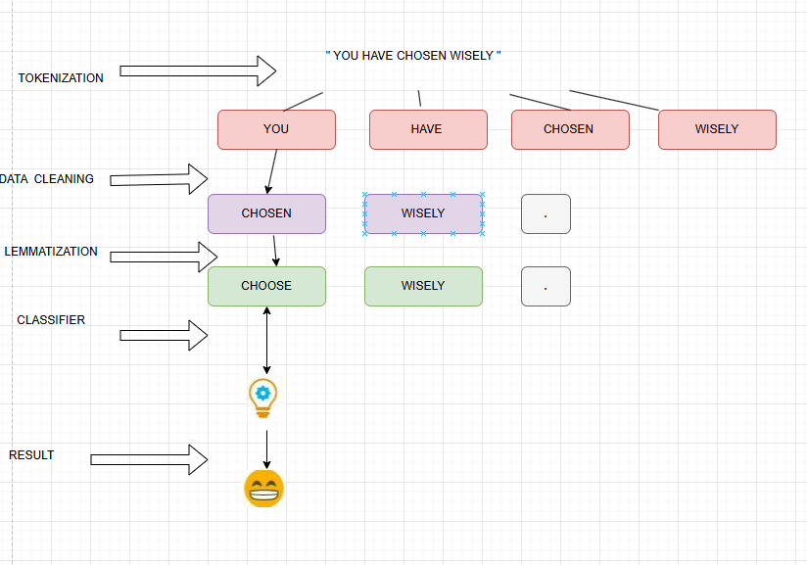

FINAL SUMMARY

This innovation presents a novel method of evaluating emotions through the application of Artificial Intelligence, Data Structures, and Probability Theory.

The differences between this model and existing methods include:

• Converting emotions to structured expressions
• Making use of mathematical evaluations
• Evaluating through stack operations for increased precision

This method guarantees:
• Greater interpretability
• Efficient computing
• Real-time adaptability

